WWU Elementary Education: Lesson Observation Form (Option A)
Date/Time: | Intern: | Field Supervisor:
Cooperating Teacher: | Length of Observation: | Lesson Topic:
Subject/Grade Level: | Observation completed by: _____ Field Supervisor _____ Cooperating Teacher

During the student teaching internship, interns shall demonstrate increased knowledge, understanding, and application of the Interstate Teacher Assessment and Support Consortium (InTASC) Standards. The WWU Student Teaching Rubrics provide a continuum of observable behaviors that an observer can document. As you observe the intern for a full lesson or just a smaller segment of time, record both teacher intern and learner actions. Learner actions provide a lens through which to observe the impact of the intern’s decisions and actions on learners. After your observation, we encourage you to have a coaching conference with your student teaching intern, focusing on the evidence from your observation.
** Most observations should focus on just 1-2 standards to provide focus for you and the student teaching intern. After you identify the focus standards, consider the guiding questions in the standard(s) on the next page and the Stoplight Model for your post-lesson coaching conference):
WWU Elementary Education InTASC Standards
(Please check the box next to the standards observed and discussed)
☐ Standard 1. Learner Development ☐ Standard 2. Learning Differences ☐ Standard 3. Learning Environments
☐ Standard 4. Content Knowledge ☐ Standard 5. Application of Content ☐ Standard 6. Assessment
☐ Standard 7. Planning for Instruction ☐ Standard 8. Instructional Strategies ☐ Standard 9. Prof. Learning and Ethical Practice
☐ Standard 10. Leadership and Collaboration

Observation Notes:

Evidence of Student Learning:

Effective Practices (The student teacher and observer can complete this section together during the post-conference):
Supports for students’ learning and effective teaching strategies

Growth areas and Next Steps to support student learning (Include specific suggestions, support strategies, and timeline for completion):
Next steps for student learning:

Next Steps for you:
WWU Elementary Education InTASC Standards
(Please check the box next to the standards targeted for the teaching intern’s next steps)
☐ Standard 1. Learner Development ☐ Standard 2. Learning Differences ☐ Standard 3. Learning Environments
☐ Standard 4. Content Knowledge ☐ Standard 5. Application of Content ☐ Standard 6. Assessment
☐ Standard 7. Planning for Instruction ☐ Standard 8. Instructional Strategies ☐ Standard 9. Prof. Learning and Ethical Practice
☐ Standard 10. Leadership and Collaboration

Elementary Education InTASC Standards Guiding Questions
Note to observer: Most observations should focus on just 1-2 standards to provide focus for you and the student teaching intern. After you identify the focus standards. Please consider these guiding questions from the InTASC standard(s) and the Stoplight Model for your post-lesson coaching conference. Use Form A or Form B to record your observations and conference notes.
Standard #1: Learner Development.  How and to what extent does the intern…  - implement developmentally appropriate instruction that accounts for learner’s strengths, interests, and needs?  - engage learners in activities designed to provide opportunities to practice communication and social skills?  - provide opportunities for learners to develop individual needs in each area of development (cognitive, linguistic, social, emotional, physical)? | Standard 6: Assessment  How and to what extent does the intern…  - use and adapt multiple assessments aligned to learning targets and implement required assessment accommodations?  - document, analyze, and interpret assessment data to identify learning trends and use to differentiate learning experiences?  - engage learners in understanding and identifying quality work and provide opportunities for learner self-reflection, self-assessment, and revision?  - provide learners with specific, criteria-based feedback focused on strengths or next steps?
Standard #2: Learning Differences  How and to what extent does the intern…  - differentiate instruction for learners needing extra support or challenge and implement interventions, modifications, and accommodations for learners with IEPs, 504 plans, and other disabilities and language learning needs?  - demonstrate knowledge of and respect for learners’ personal, family, and community experiences and cultural norms and incorporate these diverse perspectives into learning experiences and interactions? | Standard 7: Planning for Instruction  How and to what extent does the intern…  - develop measurable learning targets from curriculum materials and content standards?  - plan tasks, materials and assessments aligned to learning goals?  - plan a variety of logically sequenced learning experiences with effective pacing?  - plan for instruction based on general formative and summative assessment data?  - collaborate with CT on daily, unit, and long-range planning?
Standard #3: Learning Environments  How and to what extent does the intern…  - maximize instructional time through effective transitions and routines establish/uphold clear expectations?  - collaborate with learners to develop classroom norms that foster a positive, inclusive, and inquiry-based classroom culture?  - model supportive listening and respectful communication and promote/guide positive peer interaction?  - coordinate and allocate space, resources, and materials in ways that minimize loss of instructional time and ensures safety, accessibility, and cultural responsiveness? | Standard #8: Instructional Strategies  How and to what extent does the intern…  - vary roles between instructor, facilitator, guide, and audience and offer student choice for content/topic when appropriate?  - use varied interactive media and tech to support student learning and guide learners to use tech appropriately, safely, and effectively?  - offer a variety of anchor charts, graphic organizers, and models as scaffolds linked to explicit learning objectives, content standards, academic language, and learner needs?
Standard #4: Content Knowledge  How and to what extent does the intern:  - accurately and effectively communicate concepts, processes, and knowledge in the disciplines?  - anticipate common (mis)understandings and address them independently through consultation with resources and/or colleagues? | (InTASC Standards 9-10 are not approached during teaching, but can/should be approached throughout the internship quarters)  Standard #9: Professional Learning and Ethical Practice.  How and to what extent does the intern…  - reflect on student learning and instructional practice to identify ways to improve teaching?  - engage actively in provided professional learning opportunities?  - week, accept, reflect, and act upon feedback from colleagues to improve teaching effectiveness?  - meet professional expectations for conduct; support local/state curricula, policies, and initiatives; follow and ask questions about laws and ethical codes of conduct?
Standard #5: Applications of Content  How and to what extent does the intern…  - help learners explore relationships across disciplines through integration of differing content areas in lessons?  - explore complex problems with real-world connections related to the content areas?  - pose open-ended questions to elicit critical thinking and encourage students to use multiple strategies to explain their thinking?  - guide learners to gather, organize, and evaluation information and ideas from varied resources and perspectives? | Standard #10: Leadership and Collaboration  How and to what extent does the intern…  - participate on instructional teams and take on leadership roles as offered?  - use advice/support from colleagues and participate in efforts around school-wide vision and supportive culture?  - communicates consistently and in cultural relevant ways with families to support learner growth and elicit information about learners and their experiences?

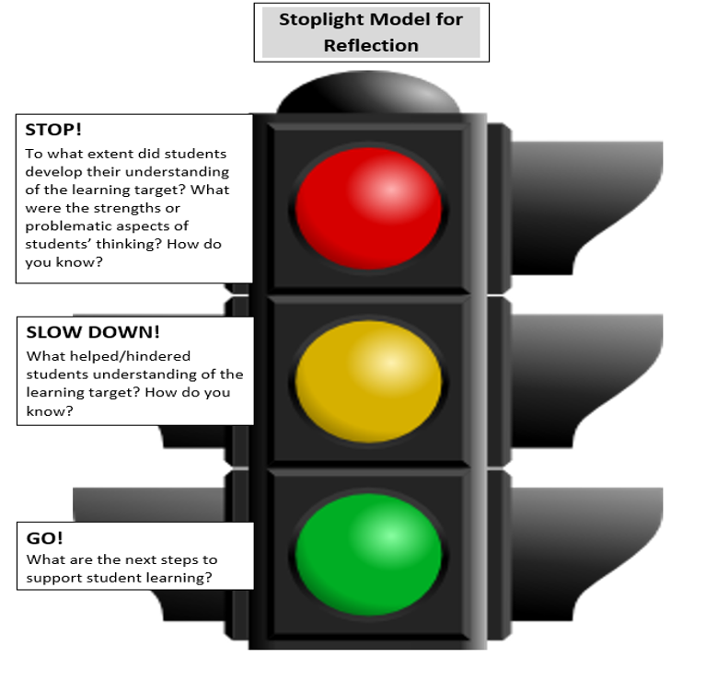

Post-observation conference notes and next steps:

