STEP 1: Log into OSPI’s EDS system

EDS Login

STEP 2: Click on Manage Your PD

STEP 3: Click to add new hours

STEP 4: Complete the requested information—example below
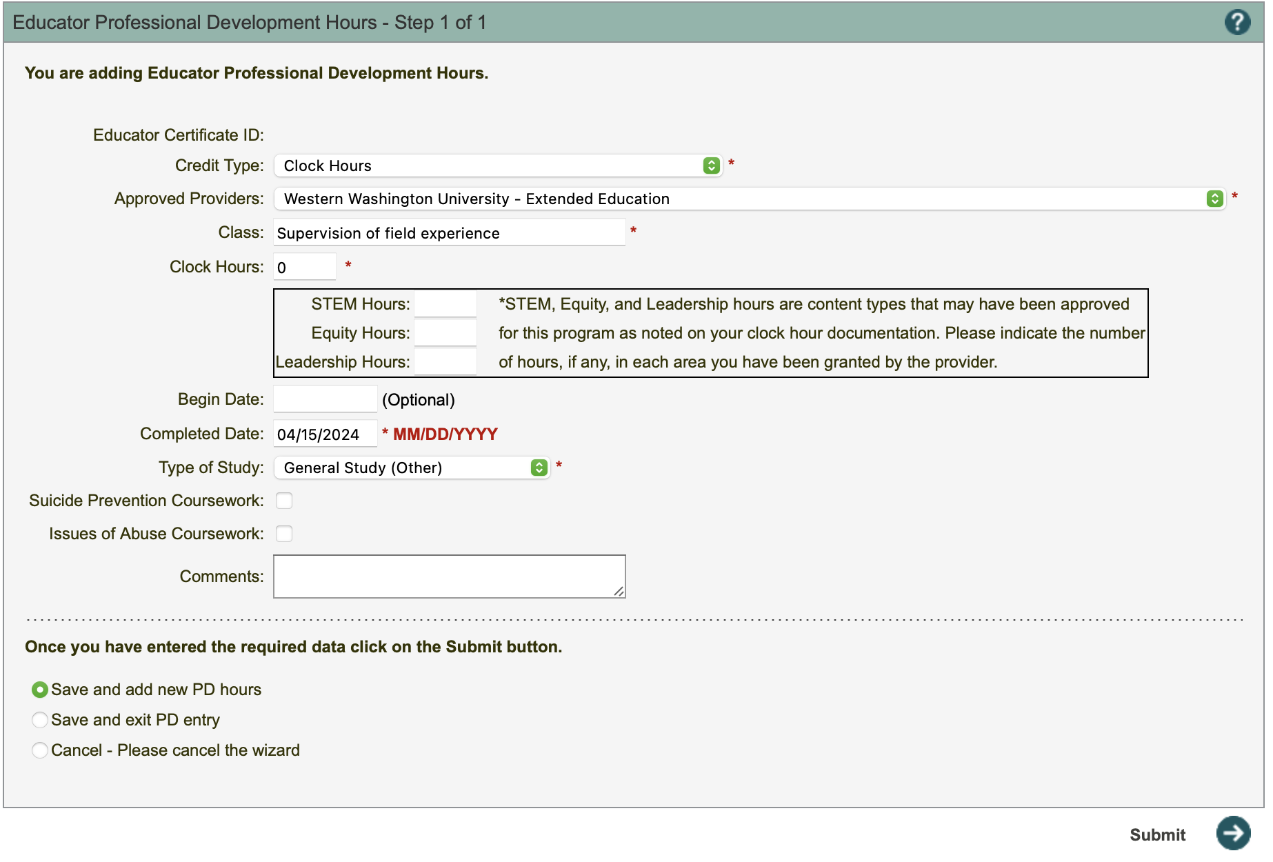
STEP 5: Submit and keep a copy of the form for your records

